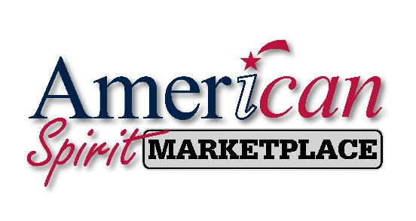
Dear Patriotic Conservative Friend,

I am writing to inform you I am an Affiliate Marketer for the American Spirit Movement. We have built a private, secure, online, login-credentialled community called the American Spirit MARKETPLACE. Our mission is to bring Conservative Consumers and Businesses together in the areas of Commerce, Employment, Business-networking, Education, and Idea-sharing.
When my friends, family, business associates, etc. join the American Spirit MARKETPLACE I earn an affiliate referral which helps me to earn extra income for doing something I believe in and am excited to be a part of! This means a lot to me…
The American Spirit MARKETPLACE is special. The Founder/CEO is an immovable object within Conservatism. This is an effective way for regular, everyday, grassroots Conservatives to “DO SOMETHING!” to help defund Liberalism and fight back against Leftism! They own and manage their own servers. There’s a strict “no selling anyone’s data” policy. No annoying clickbait ads. No spamming. I especially love our tagline because it’s exactly what we’re doing. We’re “Keeping Conservative Dollars in Conservative Pockets!”.
We have very clear Mission / Vision / Promise statements as well as clearly defined “Pillars of Principles”. These things are also very important to me as a Patriotic Conservative. I am also very fond of their “Two Votes” concept where they emphasize we have 2 very important votes in America. Our first vote must always be at the ballot box and our SECOND vote is where we vote with our Conservative dollars - at the cash register – supporting Conservative-owned small businesses.
Please review the attached PDF file and join through my link below so you too can join the American Spirit MARKETPLACE. After you join, please help me spread the word by referring me to fellow Patriotic Conservatives you know who would join as a Business or Consumer member!
Yours truly,
{Insert your name here}
Here is my affiliate link to join the American Spirit MARKETPLACE:
{Paste your link here}

